**“Education Through Self-help is our motto”-Karmaveer**



**RAYAT SHIKSHAN SANSTHA’S**

**DHANANJAYRAO GADGIL COLLEGE OF COMMERCE, SATARA**

**An Autonomous College Affiliated to Shivaji University, Kolhapur**

**DEPARTMENT OF COMPUTER APPLICATION Year-(2023-24)**

**A**

**PROJECT REPORT**

**ON**

**“GRAPHICS PHOTO STUDIO”**

SUBMITED TO

**SHIVAJI UNIVERSITY, KOLHAPUR**

**FOR THE PARTIAL FULFILLMENT OF REQUIREMENT**

**FOR THE AWARD OF THE DEGREE OF**

**“BACHELOR OF COMPUTER APPLICATION (SEM-VI)”**

**BCA-III (Sem-VI)**

SUBMITTED BY

**More Sanjana Sanjay**

**Salunkhe Pragati Mangesh**

**Gaikwad Diksha Pandharinath**

**Pawar Sanika Jeevan**

UNDER THE GUIDANCE OF

**Mr. A. S. Thombare**

Through

**2023-24**

“Education Through Self-help is our motto”-Karmaveer



**RAYAT SHIKSHAN SANSTHA’S**

DHANANJAYRAO GADGIL COLLEGE OF COMMERCE, SATARA

AN AUTONOMOUS AFFILIATED TO SHIVAJI UNIVERSITY, KOLHAPUR

(NAAC reaccredited with ‘A++’ grade CGPA 3.51ISO-9001:2023 recertified UGC-CPE)

**Recommendation Of Principal**

This is to certify that **More Sanjana Sanjay , Salunkhe Pragati Mangesh , Gaikwad Diksha Pandharinath and Pawar Sanika Jeevan** is the bonafede student studying at Dhananjayrao Gadgil College of Commerce, Satara**. BCA-III (SEM-VI).** They have completed the project report entitled “Graphics Photo Studio website” under the guidance of Assistance Professor Mr.A.S.Thombare fulfilment of the degree of “Bachelor Of computer Application” (semester -VI) program for the academic year 2023-24.

To the best my knowledge and belief, this is their original work and not submitted earlier, anywhere for any purpose in any university.

Place: - SATARA.

Date: - / /2024.

Dr.D.K.Mhaske,

PRINCIPAL,

DHANANJAYRAO GADGIL COLLEGE OF COMMERCE,

SATARA.

“Education Through Self-help is our motto”-Karmaveer



RAYAT SHIKSHAN SANSTHA’S DHANANJAYRAO GADGIL COLLEGE OF COMMERCE, SATARA

AN AUTONOMOUS AFFILIATED TO SHIVAJI UNIVERSITY, KOLHAPUR

(NAAC reaccredited with ‘A++’ grade CGPA 3.51ISO-9001:2023 recertified UGC-CPE)

**“Department Of Computer Application”**

This is to certify that More Sanjana Sanjay , Salunkhe Pragati Mangesh , Gaikwad Diksha Pandharinath and Pawar Sanika Jeevan is/are the bonafede student studying at Dhananjayrao Gadgil College of Commerce, Satara. BCA- III(SEMVI). They have completed the project report entitled “Graphics Photo Studio Website” under the guidance of Assistance Professor Mrs.A.S.Thombare for Partial fulfilment of the project report.

Mr.A.S.Thombare External Examiner Mrs.V.S.Ghadage

(Project Guide)

Place: - SATARA.

Date: - / /2024.

Head

(Dept. Of Computer Application)

**DECLARATION**

To,

The principal,

Dhananjayrao Gadgil College of Commerce, Satara 415001.

Respected Sir,

We hereby declare that the project report entitled "Graphics Photo Studio Website” is submitted to Shivaji University, Kolhapur for the partial fulfilment of requirement of award of the BCA-III yr. SEM-VI course under the guidance and supervision of Assistant Professor Mr.A.S.Thombare The empirical finding in the project is based on the data collection done by us while preparing the project report. The content of this project is not copied from any report. If it is found, we are liable for the punishment by the university.

We further declare that we have not previously submitted this project report to any other institute / university for any other degree/ diploma or to any other person.

Yours Sincerely,

|  |  |  |
| --- | --- | --- |
| STUDENTS NAME | EXAM SEAT NO. | Signature |
| More Sanjana Sanjay |  |  |
| Salunkhe Pragati Mangesh |  |  |
| Gaikwad Diksha Pandharinath |  |  |
| Pawar Sanika Jeevan |  |  |

Acknowledgement

I take An Opportunity To thank All those who have directly inspired

and helped me towards successful completion of this project report. I express my sincere Thanks to Principal Dr. D.K. Mhaske sir, Dhananjayrao Gadgil College of Commerce, Satara. For his encouragement for the project. I am also thankful to Ms.V.S.Ghadage (Head, Department of BCA).

I am thankful to my Project guide Assistance Professor Mr.A.S.Thombare sir For her Highly encouraging and Co-operative and our college librarian also gives us valuable guidance. I express my sense of gratitude towards my friends and parents for the constant moral support during my project report.

Place: - Satara. Date: - / /2024.

**INDEX**

|  |  |  |
| --- | --- | --- |
| Sr.No | Topic Name | Page No. |
| 1. | **Introduction to project**   * 1. Introduction   2. Problem Statement   3. Need & Scope |  |
| 2. | **Proposed System**  2.1 Objectives  2.2 Assumptions and Hypothesis |  |
| 3. | **System Analysis**  3.1 System Diagram  3.2 Use case Diagram |  |
| 4. | **Implementation**  4.1 System Requirement  4.2 Hardware  4.3 Software |  |
| 5. | **Source Code** |  |
| 6. | **Output Of The Project** |  |
| 7. | **Conclusion** |  |
| 8. | **References**  8.1 Website  8.2 Books |  |

**Introduction to project**

* Introduction
* Problem Statement
* Need & Scope

**Introduction to project**

* 1. **Introduction:**

Introduction

Being present online is crucial for photo studios. It helps to attract new clients and grow the business more efficiently, especially when done creatively. However, getting a photo studio website is often too expensive. Fortunately, many free web platforms allow companies to present photo studios online inexpensively and effectively. In this article, you'll learn why a free website is the best choice for your photo studio and how to create a successful photo studio site without any effort. Then we'll help optimize a photo business online presence and advertise a photo studio on a budget.

Online presence is essential in the modern business world, especially in the case of photo studios. With a website, a photo studio can present itself and its services online and thus reach out to more potential clients. In addition, a well-designed website gives any studio a professional look, which is important for clients looking for reliable photographers.

In addition to attracting more new clients, a website allows your business to retain loyal audiences. For example, you can provide information about upcoming promotions or offer clients the option to make an appointment online. This makes communication easier and increases customer loyalty in a snap.

With a website, your photo business receives an opportunity tobecome known far beyond the local market, reaching larger audiences. This is especially useful for photo studios that focus on certain niches.

A website is also a cost-effective way to draw attention to your photo studio and attract new clients. With sharply targeted on…

* 1. **Problem Statement:**

It’s been quite some time since the authorities, as well as the vast majority of the public, accepted photography as an art form. Since then photographs have been hung at art galleries and appreciated as such. But does photography really qualify as an art? Up until this point, art was something that had the emotions and the interpretation of the artist, yet photography lacks both.

With the current technology of our age almost any work of art can be mechanically reproduced, lowering that particular piece from its divine pedestal to our level. However this doesn’t necessarily destroy the “aura” of the piece, diminishing its value as a work of art, as it does not add any new interpretations to the original.

Photographs are accepted to be objective, which is the main reason they are commonly used as evidence in law. It is their “passivity” as Sontag puts it, which actually leads to the notion that they represent the truh as it is. Yet there are many photographs that distort the truth so obviously that they actually emphasize the line between representations and reality

**Need & Scope**

**Needs :**

Online presence is essential in the modern business world, especially in the case of photo studios. With a website, a photo studio can present itself and its services online and thus reach out to more potential clients. In addition, a well-designed website gives any studio a professional look, which is important for clients looking for reliable photographers.

In addition to attracting more new clients, a website allows your business to retain loyal audiences. For example, you can provide information about upcoming promotions or offer clients the option to make an appointment online. This makes communication easier and increases customer loyalty in a snap.

**Scope :**

With a website, your photo business receives an opportunity to become known far beyond the local market, reaching larger audiences. This is especially useful for photo studios that focus on certain niches.

A website is also a cost-effective way to draw attention to your photo studio and attract new clients. With sharply targeted online marketing, such as search engine optimization and online advertising, you can attract customers and build credibility faster and easier.With the rise of social media and advertising, the Photography career has reached great heights. You can work as a wildlife photographer, fashion photographer, wedding photographer, travel photographer, commercial photographer and much more. Photographers can work in the advertising industry for newspaper publishers, press and magazines. Food photography is a relatively new concept but is becoming increasingly popular.

This opens up job opportunities for photographers in the food production industries. A photographer can even start his or her studio or do freelancing work. They can teach photography courses and act as mentors for interns and graduate students. These jobs offer not only handsome salaries but also in prestigious positions. Photography is an internationally acclaimed art form. Employment opportunities for photographers are plenty abroad.

**Proposed System**

* Objectives
* Assumptions and Hypothesis
* **Proposed System**

**2.1 Objectives:**

A typical photography website’s objective is to show off photos or images in a way that will attract new clients. This is somewhat different than most business websites, where the primary objective is to make a sale. Insofar as photograph is an art form, a photography website is also different in that there is greater room for creativity.

**Most photo portfolios have these three main elements:**

* The gallery – where you want to highlight the only the best of your offerings.
* The contact section – which should be kept as simple and accessible as possible.
* The about section – to which you’ve added a clear, concise, and interesting bio, and self-portrait. This will likely be a highly-visited page.

Photography websites tend to be visually rich. On the other hand, the design approach you take should be quite subtle – even minimalist. The purpose is to highlight the photos, and not the website’s design characteristics. Excessive clutter can be distracting, and draw your visitors’ attention away from the photos; the exact opposite of what you want to happen.

**Advice for Your Client on Creating a Great Photo Portfolio**

Your client may already know how to build a great portfolio. If so, so much the better. He or she may not however be familiar with the ins and outs of creating a great online portfolio, and will probably need your guidance and assistance to do so.

**Here are some tips to share with your client for optimizing his or her portfolio:**

* **Consider the Target Demographic –** The portfolio might belong to a wedding photographer, a commercial photographer, a food photographer, or a fashion photographer. Each portfolio would require a layout that would appeal to a certain demographic.
* **High-Res Images are All-Important –** Potential clients will expect nothing less that high-resolution photos. They are looking for quality at its best; so, don’t give them anything less. Include a single low-resolution photo, and guess which photo will stand out.

**2.2 Assumptions and Hypothesis**

**Assumptions:**

1. Clients are seeking high-quality, creative, and visually appealing graphic photography services.

2. There is a demand for graphic photo studios that offer a combination of technical expertise and artistic vision.

3. The market for graphic photography services is competitive, but there is room for a studio that stands out with its unique style and approach.

4. Collaborating with clients to understand their brand, message, and goals will result in more effective and impactful visual content.

5. Utilizing advanced photography equipment, editing software, and techniques will enhance the quality of the final images.

**Hypotheses:**

1. By offering a diverse range of services such as portrait photography, product photography, event coverage, and creative conceptual shoots, the studio will attract a wider range of clients.

2. Implementing a strong branding strategy and marketing campaign will increase visibility and attract potential clients to the studio.

3. Providing exceptional customer service and building strong relationships with clients will result in repeat business and positive referrals.

4. Investing in ongoing training and development for staff members will ensure that the studio stays current with industry trends and maintains a high level of expertise.

5. Collaborating with other creative professionals such as graphic designers, stylists, and art directors will lead to innovative and unique visual projects that set the studio apart from competitors.

**System Analysis**

* System Diagram
* Use case Diagram
* **Site Map**
* **Flow Chart**

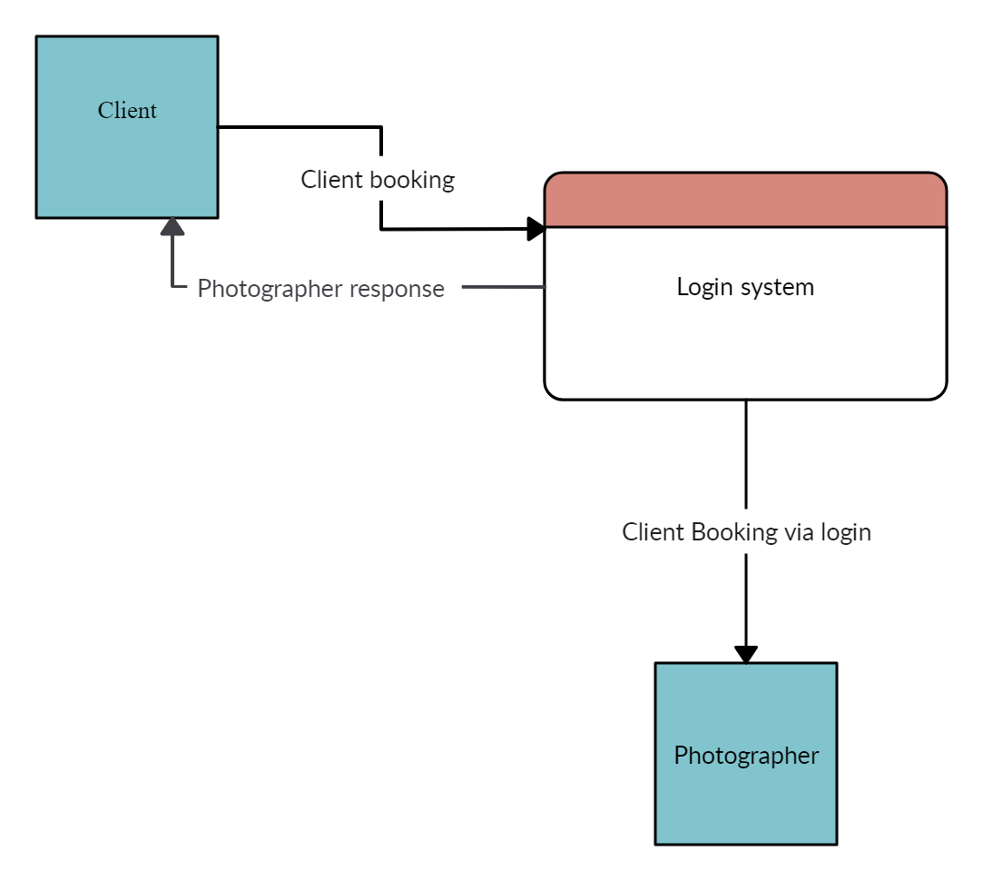

* **ERD**

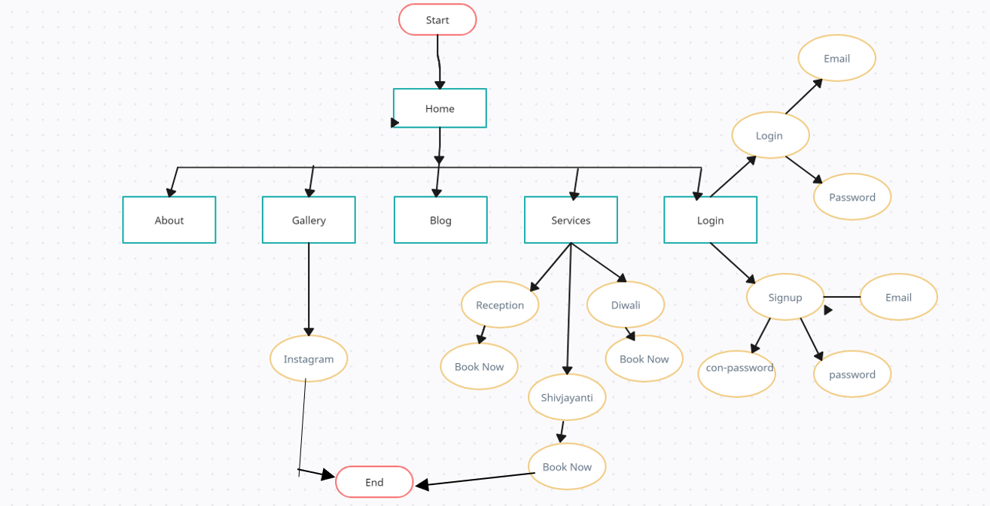

**Implementation**

* System Requirement
* Hardware
* Software

**Implementation**

System Requirement

1. **Hardware requirement**
   * A computer or laptop.
   * Reliable internet connection for accessing the website.

#### Software requirement

* + Operating system (e.g., Windows, Linux, macOS)
  + Html and CSS for website design and layout
  + Text editor or integrated development environment (IDE)for coding

**Source Code:**

**Source Code:**

<!DOCTYPE html>

<html lang="en">

<head>

<meta charset="UTF-8">

<meta http-equiv="X-UA-Compatible" content="IE=edge">

<meta name="viewport" content="width=device-width, initial-scale=1.0">

<title>Graphics Photography</title>

<!-- ========== FontAsowome Link ========== -->

<link rel="stylesheet" href="assets/css/all.min.css">

<!-- ========== Bootstrap Link ========== -->

<link rel="stylesheet" href="assets/css/bootstrap.min.css">

<!-- ========== Main Css Link ========== -->

<link rel="stylesheet" href="assets/css/style.css">

<!-- ========== Responsive Css Link ========== -->

<link rel="stylesheet" href="assets/css/responsive.css">

</head>

<body data-bs-spy="scroll">

<!-- ========== Back To Top Part Start ========== -->

<a id="button"></a>

<!-- ========== Back To Top Part Start ========== -->

<!-- =========== Navbar Part Start ========== -->

<nav class="navbar navbar-expand-lg">

<div class="container">

<button class="navbar-toggler" type="button" data-bs-toggle="collapse" data-bs-target="#navbarSupportedContent" aria-controls="navbarSupportedContent" aria-expanded="false" aria-label="Toggle navigation">

<span class="navbar-toggler-icon"></span>

</button>

<div class="collapse navbar-collapse" id="navbarSupportedContent">

<ul class="navbar-nav ms-auto mb-2 mb-lg-0">

<li class="nav-item">

<a class="nav-link active" aria-current="page" href="#home">HOME</a>

</li>

<li class="nav-item">

<a class="nav-link" href="#about">ABOUT</a>

</li>

</li>

<li class="nav-item">

<a class="nav-link" href="#portfolio">GALLREY</a>

</li>

</li>

<li class="nav-item">

<a class="nav-link" href="#jornul">BLOG</a>

</li>

</li>

<li class="nav-item">

<a class="nav-link" href="#service">SERVICES</a>

</li>

</li>

<li class="nav-item">

<a class="nav-link" href="#contact">CONTACT</a>

</li>

<li class="nav-item">

<a class="nav-link" href="login.html">LOGIN</a>

</li>

</div>

</div>

</nav>

<!-- =========== Navbar Part End ========== -->

<!-- =========== Banner Part Start ========== -->

<section id="home">

<div class="banner-img">

<div class="container">

<div class="row">

<div class="col-lg-12">

<div class="banner-text">

<h1>Graphics</h1>

<h2>Photography</h2>

<p>Click for once 📸</p>

</div>

</div>

</div>

</div>

</div>

</section>

<!-- =========== Banner Part End ========== -->

<!-- =========== About Part Start ========== -->

<section id="about">

<div class="container">

<div class="row">

<div class="col-lg-12">

<div class="tittel">

<h1>Hello! I’m Prashant, a freelance Photographer.</h1>

<p>At Graphic photo studio, we believe that every moment is worth capturing. Our team of passionate photographers combines technical expertise with an artistic eye to create stunning visual narratives. Whether it’s weddings, portraits, or corporate events, we’re dedicated to preserving memories that last a lifetime.

Let us frame your story through the lens! 🌟. </p>

</div>

</div>

<div class="col-lg-12">

<div class="tittel_2">

<h2>What services do I offerWhat services do I offer</h2>

</div>

</div>

<div class="service-crad">

<div class="row">

<div class="col-lg-4">

<div class="service-img">

<img src="assets/image/p1.jpeg" alt="Card.jpg">

<div class="service-text">

<h3>Reception PhotoShoot</h3>

<p>“Capturing love’s radiant moments in every frame.” 📸❤️ </p>

</div>

</div>

</div>

<div class="col-lg-4">

<div class="service-img">

<img src="assets/image/p2.jpeg" alt="Card_1.jpg">

<div class="service-text">

<h3>Diwali PhotoShoot</h3>

<p>“Capturing the Festival of Lights in every frame.” 📸✨. </p>

</div>

</div>

</div>

<div class="col-lg-4">

<div class="service-img">

<img src="assets/image/p3.jpeg" alt="Card_2.jpg">

<div class="service-text">

<h3>Shivjayanti PhotoShoot</h3>

<p>“Where heritage meets pixels: Shivjayanti memories forever.” 🚩📷</p>

</div>

</div>

</div>

<div class="col-lg-4">

<div class="service-img">

<img src="assets/image/p4.jpeg" alt="Card_2.jpg">

<div class="service-text">

<h3>Birthday Blast</h3>

<p>“Capturing joy, laughter, and unforgettable moments on your special day.” 🎂📸</p>

</div>

</div>

</div>

<div class="col-lg-4">

<div class="service-img">

<img src="assets/image/p5.jpeg" alt="Card_2.jpg">

<div class="service-text">

<h3>Pre-Wedding PhotoShoot</h3>

<p>“Capturing love’s anticipation and romance before the big day.” 📸❤️</p>

</div>

</div>

</div>

<div class="col-lg-4">

<div class="service-img">

<img src="assets/image/p6.jpeg" alt="Card_2.jpg">

<div class="service-text">

<h3>Wedding PhotoShoot</h3>

<p>“Where vows meet visual poetry: Our wedding photography magic.” 🌟📷</p>

</div>

</div>

</div>

<div class="col-lg-4">

<div class="service-img">

<img src="assets/image/p7.jpeg" alt="Card_2.jpg">

<div class="service-text">

<h3>Makar Sankranti PhotoShoot</h3>

<p>“Where celebration meets the lens.” 🥳📷</p>

</div>

</div>

</div>

<div class="col-lg-4">

<div class="service-img">

<img src="assets/image/p8.jpeg" alt="Card_2.jpg">

<div class="service-text">

<h3>Engagement PhotoShoot</h3>

<p>“Capturing love’s anticipation and romance before the big day.” 📸❤️</p>

</div>

</div>

</div>

<div class="col-lg-4">

<div class="service-img">

<img src="assets/image/p9.jpeg" alt="Card_2.jpg">

<div class="service-text">

<h3>Holi PhotoShoot</h3>

<p>“The colours of holi are not just colours; they are hues of love.” 🥳📷</p>

</div>

</div>

</div>

<div class="col-lg-4">

<div class="service-img">

<img src="assets/image/p10.jpeg" alt="Card_2.jpg">

<div class="service-text">

<h3>Name ceremony</h3>

<p>“The future is now. Happy naming ceremony to our new member of the family"📸👶</p>

</div>

</div>

</div>

<div class="col-lg-4">

<div class="service-img">

<img src="assets/image/p11.jpeg" alt="Card_2.jpg">

<div class="service-text">

<h3>Baby Shower</h3>

<p>"Showering our little one with love, gifts, and endless excitement! #BabyShower"📸🥰</p>

</div>

</div>

</div>

<div class="col-lg-4">

<div class="service-img">

<img src="assets/image/p12.jpeg" alt="Card_2.jpg">

<div class="service-text">

<h3>Ganpati Festival</h3>

<p>"Ganpati Bappa Morya! Here's to a memorable and fulfilling festival"📸🌺</p>

</div>

</div>

</div>

</div>

</div>

</div>

</div>

</section>

<!-- =========== About Part End ========== -->

<!-- =========== Portfolio Part Start ========== -->

<section id="portfolio">

<div class="row">

<div class="col-lg-12">

<div class="tittel">

<h2>Latest ınstagram shots</h2>

</div>

</div>

<div class="portfolio-img">

<img src="assets/image/img.jpg" alt="img.jpg">

<img src="assets/image/img_01.jpg" alt="img_01.jpg">

<img src="assets/image/img_02.jpg" alt="img_02.jpg">

<img src="assets/image/img_03.jpg" alt="img_03.jpg">

<img src="assets/image/img_04.jpg" alt="img_04.jpg">

</div>

<div class="tittel">

<div class="col-lg-12">

<div class="insta-page">

<div class="icon">

<a href="https://www.instagram.com/prashant_salunkhe_photography?igsh=MzRlODBiNWFlZA==">

<i class="fa-brands fa-instagram"></i></a>

<div class="insta-text">

<p>INSTAGRAM PAGE</p>

</div>

</div>

</div>

</div>

</div>

</div>

</section>

<!-- =========== Portfolio Part End ========== -->

<!-- =========== JORNUL Part Start ========== -->

<section id="jornul">

<div class="container">

<div class="row">

<div class="col-lg-12">

<div class="tittel">

<h2>From the Journal</h2>

</div>

</div>

<div class="jornul-card">

<div class="row">

<div class="col-lg-4">

<div class="jornul-item">

<div class="top-text">

<h2>“Campus Chic: A Photographic Journey Through College Girl Fashion”</h2>

<p>21.04.2014 / Photography, Journal</p>

</div>

<div class="jornul-img">

<img src="assets/image/Service.jpeg" alt="Service.jpeg">

</div>

<div class="bottom-text">

<p>Embark on a vibrant visual odyssey that celebrates the diverse and dynamic styles of college girls with "Campus Chic: A Photographic Journey Through College Girl Fashion." This blog captures the essence of contemporary female empowerment and self-expression through the lens of fashion on college campuses around the globe. From the breezy, laid-back looks of sunny Californian universities to the sophisticated, urban chic of East Coast colleges, each photo tells a story of individuality, ambition, and the unapologetic joy of youth. "Campus Chic" is more than just a photoshoot;

it's a tribute to the boldness, creativity, and spirit of young women who are shaping the future, one outfit at a time</p>

<i class="fa-regular fa-heart"></i>

<span>35</span>

</div>

</div>

</div>

<div class="col-lg-4">

<div class="jornul-item">

<div class="top-text">

<h2>“Ganpati’s Muse: A Captivating Photoshoot”</h2>

<p>21.04.2014 / Photography, Journal</p>

</div>

<div class="jornul-img">

<img src="assets/image/Service_01.jpg" alt="Service_01.jpg">

</div>

<div class="bottom-text">

<p>In the dappled glow of marigold garlands and incense-laden air, our lens weaves magic around the divine and the earthly. Welcome to a world where Ganpati Bappa meets the ethereal beauty of a model—a union of sacred and sensual.

From the intricate mehndi on her palms to the vibrant hues of her ensemble, we explore the juxtaposition of tradition and modernity. The model, adorned in silks and jewels, stands before the majestic idol, her eyes mirroring devotion and curiosity.</p>

<i class="fa-regular fa-heart"></i>

<span>27</span>

</div>

</div>

</div>

<div class="col-lg-4">

<div class="jornul-item">

<div class="top-text">

<h2>“Cherub Whispers: Capturing Baby’s First Moments”</h2>

<p>21.04.2014 / Photography, Journal</p>

</div>

<div class="jornul-img">

<img src="assets/image/Service_02.jpg" alt="Service_02.jpg">

</div>

<div class="bottom-text">

<p>In the soft glow of morning light, where innocence meets wonder, we embark on a journey to immortalize the tiniest miracles. Welcome to “Cherub Whispers,” where babyhood unfolds in delicate frames and giggles echo through time.

From the first yawn to the tiniest toes, we celebrate the extraordinary in the ordinary.</p>

<i class="fa-regular fa-heart"></i>

<span>43</span>

</div>

</div>

</div>

</div>

</div>

</div>

</div>

</section>

<!-- =========== JORNUL Part End ========== -->

<!-- =========== Service Part Start ========== -->

<section id="service">

<div class="container">

<div class="row">

<div class="col-lg-6">

<div class="left">

<div class="left-tittel">

<h2>A little about me</h2>

</div>

<div class="about-service">

<div class="service-img">

<img src="assets/image/About-pic.jpg" alt="About-pic.jpg">

</div>

<div class="service-text">

<h2> Graphic photo studio</h2>

<p>At Graphic photo studio, we believe that every moment is worth capturing. Our team of passionate photographers combines technical expertise with an artistic eye to create stunning visual narratives. Whether it’s weddings, portraits, or corporate events, we’re dedicated to preserving memories that last a lifetime. Let us frame your story through the lens! 🌟</p>

</div>

</div>

</div>

</div>

<div class="col-lg-6">

<div class="right">

<div class="right-tittel">

<h2>My Services</h2>

</div>

<div class="service-item">

<div class="service-icon">

<img src="assets/image/icon.png" alt="icon.png">

</div>

<div class="text">

<h2>Photography</h2>

<p>"We specialize in Maharashtrian Wedding, Indian Wedding, Reception, Engagement, Pre-wedding Shoots, Couple Portraits, and Bridal Portraits. Our offerings include Promo Videos, HD Videos, Coffee Mugs, Posters, HD Highlights, Photobooks, Frames, CDs/DVDs, Calendars, Enlargements, Montages, Laminations, and Coffee Table Books..</p>

</div>

</div>

<div class="service-item">

<div class="service-icon">

<img src="assets/image/icon_1.png" alt="icon_1.png">

</div>

<div class="text">

<h2>Motion Video</h2>

<p>"We specialize in Animation Video Production, creating compelling stories in motion. Our services include 2D Motion Graphics Animation, 3D Motion Graphic Design, and Title Design</p>

</div>

</div>

<div class="service-item">

<div class="service-icon">

<img src="assets/image/icon_2.png" alt="icon_2.png">

</div>

<div class="text">

<h2>Photo Retouching</h2>

<p>"We specialize in Portrait Photo Editing, Wedding, Body, Newborn, Product, Jewellery, and Photo Manipulation. Our skilled retouchers enhance skin texture, adjust colors, remove imperfections, and transform backgrounds. Whether it’s a portrait or a product, we ensure your photos look professionally edited!"</p>

</div>

</div>

</div>

</div>

</div>

</div>

</section>

<!-- =========== Service Part End ========== -->

<!-- =========== Contact Part Start ========== -->

<section id="contact">

<div class="main">

<div class="container">

<div class="row">

<div class="col-lg-3">

<div class="first">

<div class="Contact-tittel">

<h2>Get In Touch</h2>

<p>Our photo studio is just a message away! Whether you’re planning a photoshoot, have inquiries, or want to collaborate, drop us a line. We’d love to hear from you. 📸✉️</p>

</div>

<div class="first-adderes">

<div class="icon">

<i class="fa-solid fa-location-dot"></i>

</div>

<div class="text">

<a href="#">AT. Post Wathar Tal Koregaon Dis. Satara</a>

</div>

</div>

<div class="first-adderes">

<div class="icon">

<i class="fa-solid fa-phone"></i>

</div>

<div class="text">

<a href="tel:0247 541 65 87">9742355251</a>

</div>

</div>

<div class="first-adderes">

<div class="icon">

<i class="fa-solid fa-envelope"></i>

</div>

<div class="text">

<a href="#">prashantsalunkhe6469@gmail.com</a>

</div>

</div>

</div>

</div>

<div class="col-lg-3">

<div class="third">

<div class="Contact-tittel">

<h2>Popular Posts</h2>

<p>Dive into the magic that unfolds within our studio walls. From candid moments to meticulously crafted compositions, this post offers a glimpse into our artistic journey.

Discover the stories behind our favorite shots, the gear we swear by, and the passion that fuels every click. 📸✨</p>

<p>see my pupolar post on instagram</p>

</div>

</div>

</div>

<div class="col-lg-3">

<div class="forth">

<div class="Contact-tittel">

<h2>About Us</h2>

<p>Our lenses frame emotions, laughter, and love.</p>

<p> Whether it’s a wedding, a family portrait, or a corporate event, we blend creativity with technical precision to immortalize memories.

Let us be part of your journey, freezing time one click at a time. 📸✨</p>

</div>

</div>

</div>

</div>

</div>

</div>

</section>

<!-- =========== Contact Part End ========== -->

<!-- =========== Footer Part Star ========== -->

<footer>

<div class="main">

<div class="container">

<p>© pragi. All rights reserved. Theme by pragi.</p>

</div>

</div>

</footer>

<!-- =========== Footer Part End ========== -->

<!-- ========== All JS Link ========== -->

<script src="assets/js/jquery-1.12.4.min.js"></script>

<script src="assets/js/jquery-ui.min.js"></script>

<script src="assets/js/waypoints.min.js"></script>

<script src="assets/js/bootstrap.bundle.min.js"></script>

<script src="assets/js/script.js"></script>

</body>

</html>

**Login:**

<!DOCTYPE html>

<link rel="stylesheet" href="login.css">

</head>

<body>

<div class="container">

<input type="checkbox" id="check">

<div class="login form">

<header>Login</header>

<form action="login.php" method="post">

<input type="text" placeholder="Enter your email">

<input type="password" placeholder="Enter your password">

<a href="#">Forgot password?</a>

<input type="button" class="button" value="Login">

</form>

<div class="signup">

<span class="signup">Don't have an account?

<label for="check">Signup</label>

</span>

</div>

</div>

<div class="registration form">

<header>Signup</header>

<form action="registration.php" method="post">

<input type="text" placeholder="Enter your email">

<input type="password" placeholder="Create a password">

<input type="password" placeholder="Confirm your password">

<input type="button" class="button" value="Signup">

</form>

<div class="signup">

<span class="signup">Already have an account?

<label for="check">Login</label>

</span>

</div>

</div>

</div>

</body>

</html>

**CSS:**

/* Import Google font - Poppins */

@import url('https://fonts.googleapis.com/css2?family=Poppins:wght@200;300;400;500;600;700&display=swap');

*{

margin: 0;

padding: 0;

box-sizing: border-box;

font-family: 'Poppins', sans-serif;

}

body{

height: 100%;

width: 100%;

background-image: url(assets/image/log.jpg);

}

.container{

position: absolute;

top: 50%;

left: 50%;

transform: translate(-50%,-50%);

max-width: 430px;

width: 100%;

background:transparent;

border-radius: 100px;

box-shadow: 0 5px 50px rgba(0,0,0,0.3);

}

.container .registration{

display: none;

}

#check:checked ~ .registration{

display: block;

}

#check:checked ~ .login{

display: none;

}

#check{

display: none;

}

.container .form{

padding: 2rem;

}

.form header{

font-size: 2rem;

font-weight: 500;

text-align: center;

margin-bottom: 1.5rem;

}

.form input{

height: 60px;

width: 100%;

padding: 0 15px;

font-size: 17px;

margin-bottom: 1.3rem;

border: 1px solid #ddd;

border-radius: 6px;

outline: none;

}

.form input:focus{

box-shadow: 0 1px 0 rgba(0,0,0,0.2);

}

.form a{

font-size: 16px;

color: #009579;

text-decoration: none;

}

.form a:hover{

text-decoration: underline;

}

.form input.button{

color: #fff;

background: #009579;

font-size: 1.2rem;

font-weight: 500;

letter-spacing: 1px;

margin-top: 1.7rem;

cursor: pointer;

transition: 0.4s;

}

.form input.button:hover{

background: #006653;

}

.signup{

font-size: 17px;

text-align: center;

}

.signup label{

color: #009579;

cursor: pointer;

}

.signup label:hover{

text-decoration: underline;

}

**Output Of the Project**

**Output Of the Project**

**Home:**

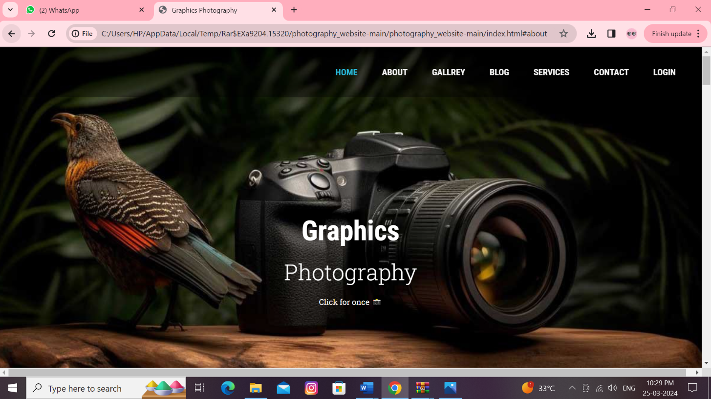

**About:**

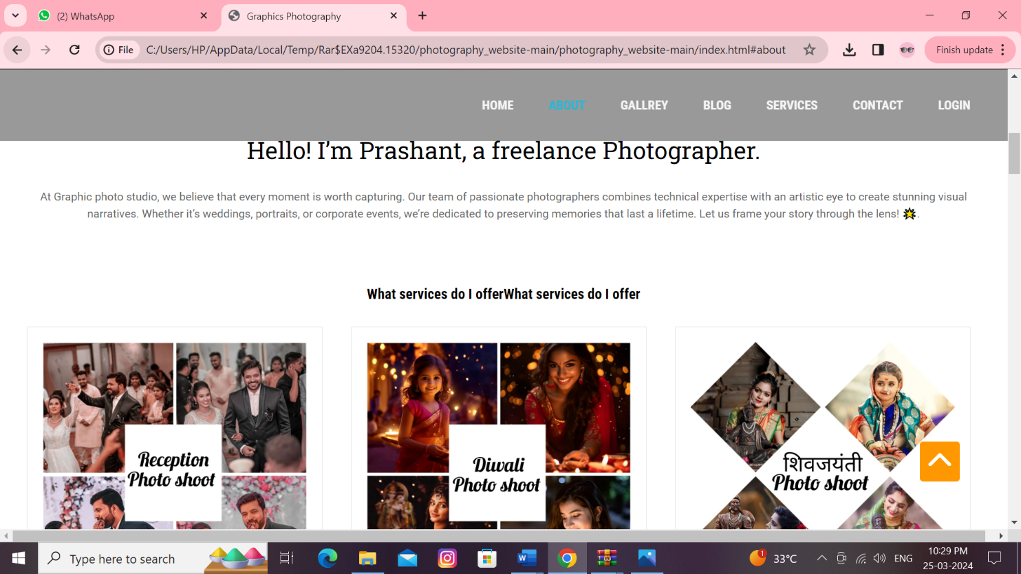

**Gallery:**

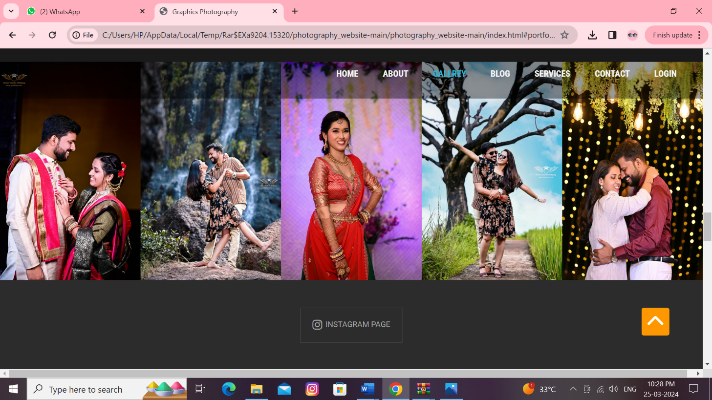

**Blog:**

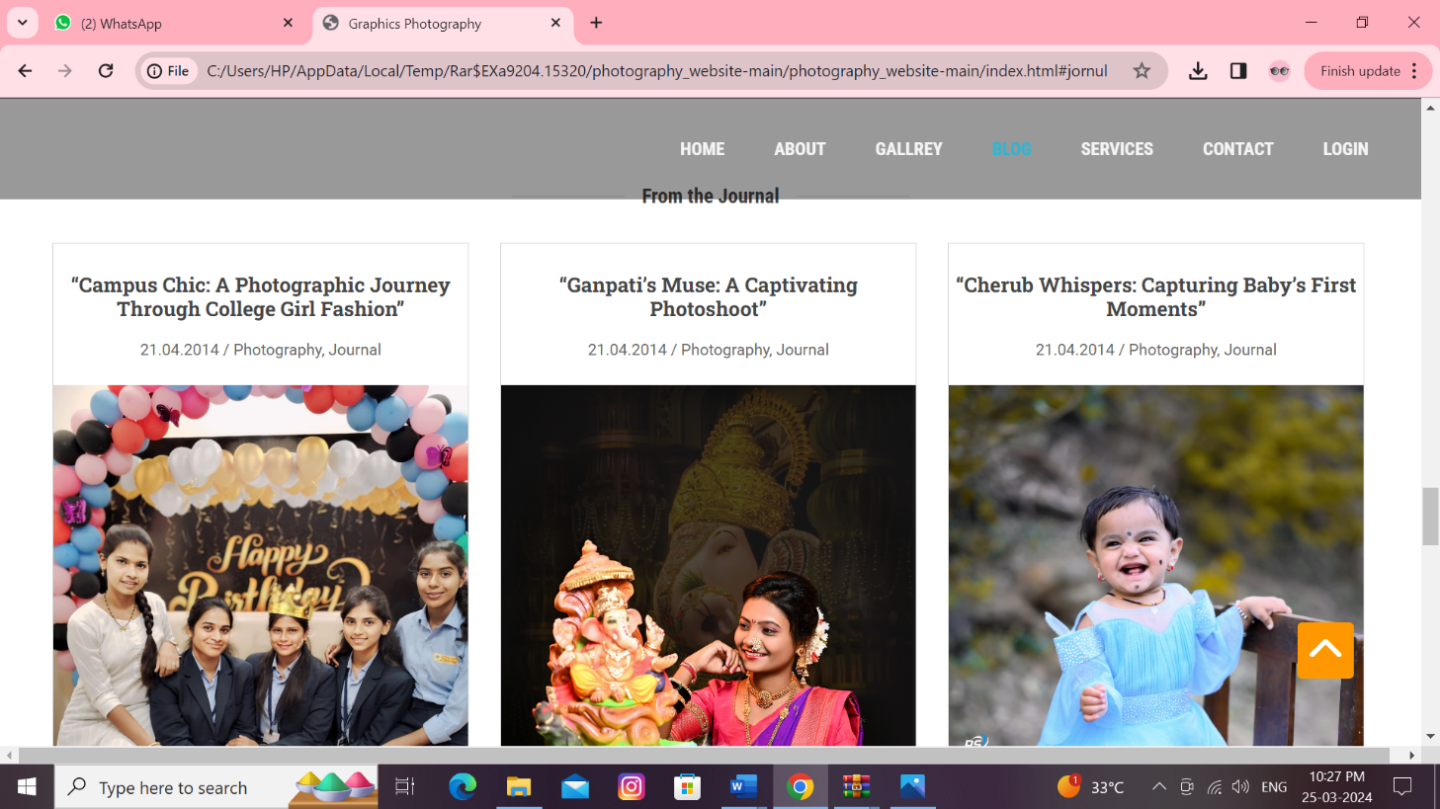

**Services:**

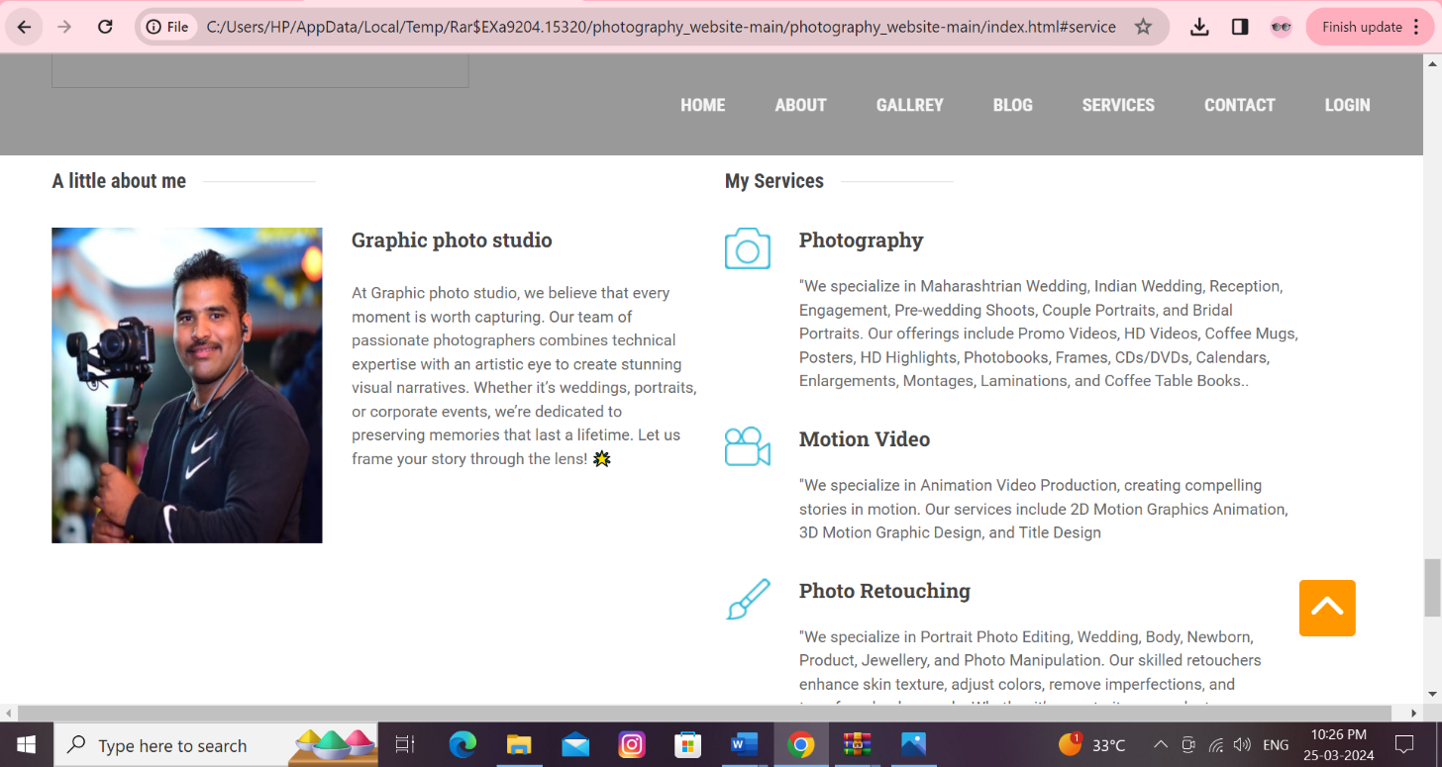

**Contact:**

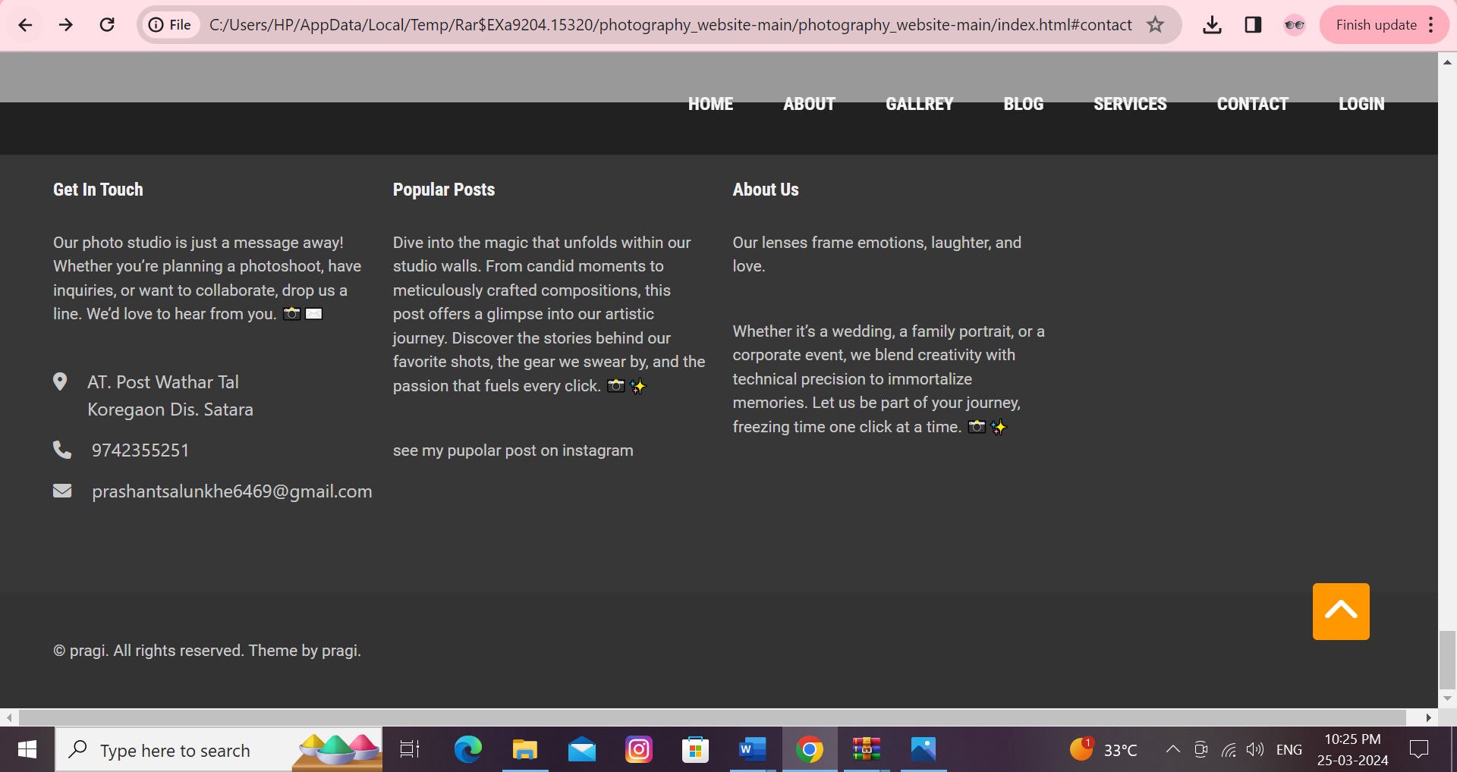

**Login:**

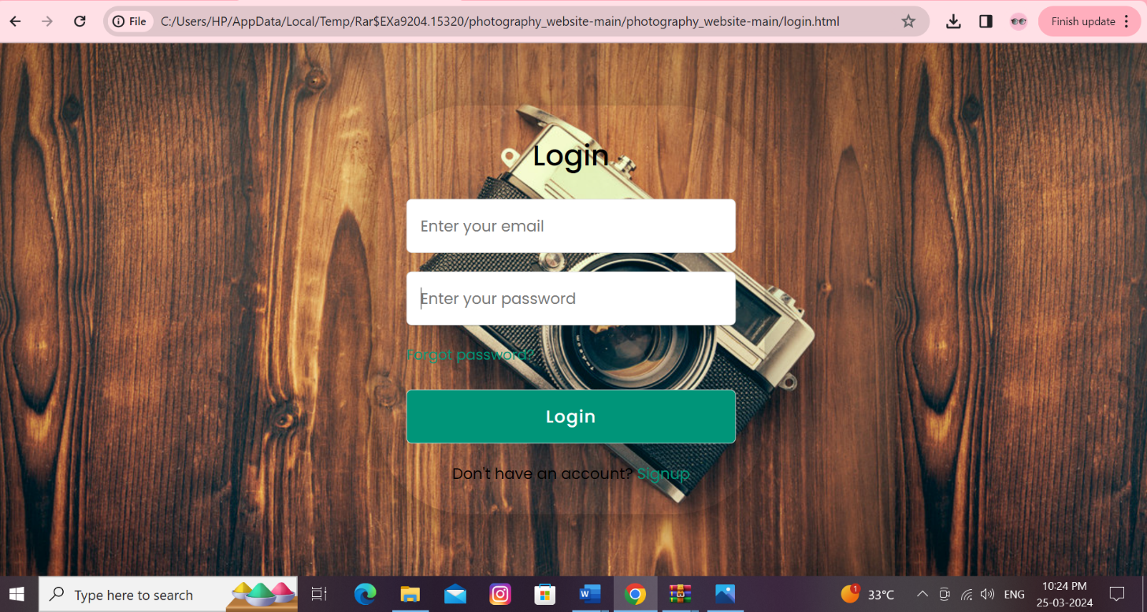

**User Manual**

If you’re interested in mastering **manual mode photography**, I’ve got you covered. Let’s dive into some helpful resources:

1. **A Step-by-Step Beginner’s Guide to Master Manual Mode Photography**:

* Written by **Prashant Salunkhe**, this comprehensive guide provides **14 ultimate tips and tricks** for shooting in manual mode. It covers essential topics like understanding optics, camera settings, and real-world application. Whether you’re a beginner or looking to enhance your skills, this guide will help you break free from the limitations of auto mode and create mind-blowing images.

1. **Manual Mode in Photography: The Complete Guide**:

* This guide, available on **PhotoWorkout**, delves into the intricacies of manual mode. It empowers you to set your **aperture**, **shutter speed**, and **ISO** precisely. By understanding these settings, you can achieve the exact results you envision. Remember, manual mode allows you to take creative control over your photography.

1. **Quick Tip**:

* If you want a **sharp background**, pick a **narrow aperture**. This helps create that beautiful background blur (also known as bokeh) that you’ve seen in professional photographs.

**Conclusion**

**Conclusion:**

In conclusion, graphic photo studios play a crucial role in helping individuals and businesses create visually appealing and impactful images. These studios provide a range of services such as photo editing, retouching, and manipulation to enhance the quality of images. With the increasing demand for high-quality visual content in today's digital age, graphic photo studios are becoming more important than ever in helping clients achieve their creative vision and stand out in a competitive market.

Additionally, graphic photo studios offer a level of expertise and creativity that can elevate the visual storytelling of any project. They have the technical skills and artistic eye to transform ordinary images into extraordinary works of art. Whether it's for personal projects, professional branding, or marketing campaigns, graphic photo studios provide a valuable resource for individuals and businesses looking to make a lasting impression through stunning visual content. By partnering with a graphic photo studio, clients can access a wealth of knowledge and resources to bring their creative ideas to life and achieve their desired visual goals.

**References**

* Website
* Books

**References**

**8.1 Website:**

* + [www.w3school.com.](http://www.w3school.com/)
  + [www.udemy.com.](http://www.udemy.com/)
  + [www.geeksforgeeks.com.](http://www.geeksforgeeks.com/)
  + [www.javapoint.com.](http://www.javapoint.com/)
  + [www.freecodecamo.com](http://www.freecodecamo.com/)
  + [www.learnmicrosoft.com](http://www.learnmicrosoft.com/)
  + [www.codeacademy.com](http://www.codeacademy.com/)
  + [www.theodinproject.com](http://www.theodinproject.com/)
  + [www.htmldog.com](http://www.htmldog.com/)
  + [www.pluralsight.com](http://www.pluralsight.com/)
  + [www.Codeschool.com](http://www.Codeschool.com/)

**8.2 Books**

1)Responsive Web Design with HTML5 and CSS

2) HTML and CSS book(Kailash Chandra Upadhyay)

3) HTML , CSS and JavaScript